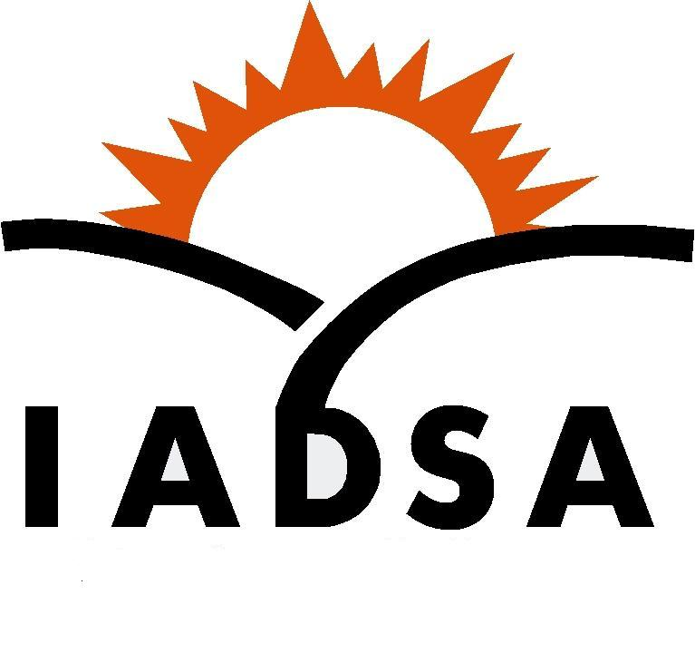
Illinois Adult Day Services Association
Membership Application Form
Revised 2020

Name: ____________________________________________________

Center Name: ____________________________________________

Center Address: __________________________________________
City: _______________________________________________________
Zip: _____________ County: ______________________
Phone: _____________________________________________________
E-mail: _____________________________________________________
Contact Person: ____________________________________
Title of
Contact Person: _____________________________________________
Make check payable to:
Illinois Adult Day Service Association
PO Box 7317
Springfield IL 62791-7317
iadsainfo@gmail.com

ADS Facility Membership...$295 (Add $50.00 per location for each satellite site).
Individual Membership…$200 (individuals not affiliated with an operational adult day service center).
Alliance Membership Dues...$500.00 (Available to organizations with interest in Adult Day - this level has no voting rights)

Please take a few minutes to complete the following information about your center. This information will be used to create a consolidated profile of Adult Day Service in Illinois. The demographics provided will be used as the Association advocates with the State, the Department on Aging, NADSA or other entities on our behalf.
- How long has your center been in operation?
____ Still in the planning stages
____ Less than one year
____ 1-5 years
____ More than 5 years
____More than 10 years

- Is your center operated by a parent corporation? ____Yes ____No
- Does your parent corporation operate more than one adult day service center? ____No _____ Total Number of ADS Centers
- What is your daily rate (average if you have multiple rates) for private pay clients? _________
- What is your unit cost? (Total annual operating cost divided by number of client days provided annually) ___________
  - Example: $340,000 annual operating expenses for ADS
250 days of operation X 25 clients per day = 6250 units per year
- UNIT COST = $54.40
- Does this unit cost include rent? ____Yes ____No
- Does your center currently have contracts with the following reimbursement sources?
  - IDOA __yes ___no
  - Veteran’s Admin ___yes ___no
  - DORS ___yes ___no
  - USDA ___yes __no
- During the most recent completed fiscal year did your center
_____Break Even _____Experience a loss
- During the most recent completed fiscal year was your center filled to capacity. __Yes ___No
- What is your capacity? ______
- What is your average daily attendance? ________
- Have members of your staff attended IADSA sponsored trainings? ____Yes ____No
- Would you be willing/able to serve on IADSA committees or projects ___Yes ___No ____Only if work is local ___Occasionally
FOR ASSOCIATION USE ONLY:
Date application/dues received _________ Amt received ______
Check # ______________

